Date: January 2024 09:15 am
Chair:
Trusts Present:
BOB ICS System Plan REMINDER PERIDASH TWICE DAILY COMPLETION
Maternity Daily Safety Calls for support and mutual aid | Daily call at 09:15am – currently ongoing agree the plan for mutual aid  - Local contingency plans (escalation Policy) in place  - Red Flag IOL’s:  - Starting=Planned IOL not commenced within 24 hours (SIT REP)  - Once in building= IOL not commenced after 2 hrs of admission (NICE)  - Next Stage=IOL once started not able to progress to next stage (either ARM, Oxytocin or CAT III LSCS) for 24 hrs or more (BOB wide agreement)  - IOL not commenced after 2 hrs of admission  In the event of any black alert – ICS on-call team will be made aware and local escalation plans continue  - Local Midwifery leaders on call will contact other maternity services to identify if mutual from providers (via instant messaging and telephone calls) need will be for labouring women  - The outcome will depend on each providers local acuity  - In the event of mutual aid maternity services make the necessary arrangement with families  - In the event of no-one being able to take the maternity service will have to manage this at risk  - Hospital on calls teams will be made aware and updated  - On black status each unit continue with ongoing reviews of status until status improves  Services will also consider boundary partners – (Frimley Park, Wexham Park (FHFT), Milton Keynes, Basingstoke based on safe travel for women in labour)
Opel status
   | BHT | OUH | RBH | FHFT | SCAS
  Staffing & acuity | Opel | Opel | Opel | Opel | Opel
  NICU & NNU | Opel | Opel | Opel | Opel
Acuity -Summary
Capacity-Summary | Any service closures occurred or planned:
SCAS-Summary of any information

Service | Acuity | Staffing | Capacity | Alert Status | NICU Status
 |  |  |  | Opel 4 | Opel 4
 |  |  |  | Opel 3 | Opel 3
 |  |  |  | Opel 2 | Opel 2
 |  |  |  | Opel 1 | Opel 1
BHT | LW  - 1:1  - 2:1 x  - OBS BAY x  - BC x  - CS x  - IOL-ongoing x  - IOL-TCI x  - Red Flag IOL x  Covid/Flu/IPC x | Hospital on calls:  Community on calls:  Home Births in progress: | Beds  - AN/PN x  - LW x  - TCU x  - OBS BAY x  - BC x  Any service closures occurred or planned: | Opel | Opel
  E | - | %
  L | - | %
  N | - | %
  BR+ | AN/PN
  BR+ | LW
  BR+ | BC
Service | Acuity | Staffing | Capacity | Alert Status | NICU Status
 |  |  |  | Opel 4 | Opel 4
 |  |  |  | Opel 3 | Opel 3
 |  |  |  | Opel 2 | Opel 2
 |  |  |  | Opel 1 | Opel 1
OUH | LW  - 1:1 x  - 2:1 x  - CS x  - IOL-ongoing x  - IOL-TCI x  - Red flag IOL x  - BC x  - HDU x  - Stand alone BC’s x  Covid/Flu/IPC x | Hospital on calls:  Community on calls:  CoC:  Home Births: | Beds  - Level 6-AN x  - LW x  - Level 5-PN x  - HDU x  - Level 7-Bereavement/PN  - BC x  - TCU x  Any service closures occurred or planned: | Opel | Opel
  E | - | %
  L | - | %
  N | - | %
RBH | LW  - 1:1 x  - 2:1 x  - HDU x  - CS x  - IOL-ongoing x  - IOL TCI x  - Red Flag IOL x  - BC x  Covid/Flu/IPC x | Hospital on-calls:  Community on-calls:  Home Births:  CoC on-call: | Beds  - AN x  - LW x  - PN x  - TCU x  - BC x  Any service closures occurred or planned: | Opel | Opel
  E | - | %
  L | - | %
  N | - | %
  BR+ | LW
  BR+ | BC
  BR+ | PN
  BR+ | AN
(WPH/FPH) FHFT | LW  - 1:1 x  - 2:1 x  - HDU x  - CS x  - IOL x  - BC x  Covid x | On calls x  HB | Beds  - AN x  - LW x  - PN x  - TCU x | Opel | Opel
  E | - | %
  L | - | %
  N | - | %
(Once completed save file on LMNS One Drive and share with trusts and ICB as per SOP)
Any other urgent issues discussed or comments:
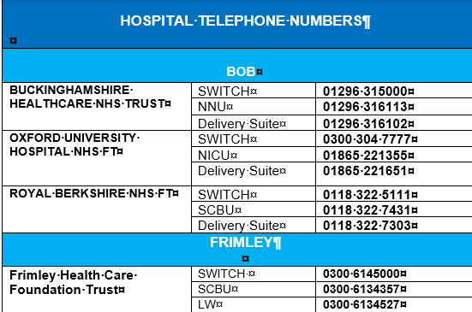 Frimley Park Direct line to labour ward 0300 6134035
Milton Keynes Labour Ward: 01980 996471

