Standard Operating Procedure for the BOB LMNS Safety Huddle

Please read with Mutual Aid Guidance and Escalation Levels Framework for Buckinghamshire Oxfordshire and Berkshire West (BOB) Local Maternity and Neonatal System (LMNS) V.1

Author | Job Title | Version | Date | Review Date
Donna Parris | Workforce & Education Partnership Lead | 1.0 | 14/07/2023
Nicky Galdeano | Quality and Safety Lead | 1.1 | 30/11/2023

Approval
Approval Group | Job title, Chair of Committee | Date
BOB LMNS Board | SRO or Deputy SRO BOB LMNS | 08.11.23

Change History
Author / Job Title | Date | Reason | Version
Nicky Galdeano, Quality and Safety Lead, BOB LMNS | 30/11/2023 | Revision of Red Flag criteria | 1.1

- Definition and Glossary of terms

LMNS | Local Maternity and Neonatal System
BOB | Buckinghamshire Oxfordshire Berkshire West
IOL | Induction of Labour
EL LSCS | Elective Lower segment caesarean section
AN | Antenatal
PN | Postnatal
HDU | High dependency unit
D/S | Delivery Suite
BC | Birth Centre

- Purpose / background

The purpose of this document is to ensure that Trusts across Buckinghamshire Oxfordshire and Berkshire West (BOB) are able to provide safe and effective care to all women and birthing people accessing Maternity Services. Any concerns regarding the ability to respond to the demands of the service are escalated at an early stage through the BOB LMNS safety Huddle with a view to offer mutual aid across the system as one means of mitigation against the need for further escalation.

To provide system-wide oversight of the pressures within the acute trusts

To ensure the LMNS are aware when services are requiring support, moving to or activating escalation or requesting mutual aid.

To ensure each service knows whether their colleagues within the system are escalating or requiring mutual aid.

To set clear expectations regarding roles and responsibilities of professionals attending the BOB LMNS Safety Huddle

Enable local trusts to maintain quality and patient safety across the system.

Provide consistency in terminology and Red Flag triggers.

To create support across the system, allow mutual aid conversations, sharing of care and information as required

- Scope

This document is for use by all professionals attending or chairing the BOB LMNS Safety huddle.

- Responsibilities

Role | Responsibility
LMNS | - To host & chair the BOB LMNS Safety Huddle across a 5-day service; Monday-Friday 9.15-9.45  - To maintain the BOB LMNS Safety Huddle chat group on WhatsApp as needed of appropriate.  - To produce and complete the BOB LMNS Safety Huddle template.  - To ensure all attendees receive a copy of the completed BOB LMNS Safety Huddle template.  - To enquire whether trusts are requesting mutual aid.  - To arrange a second Safety Huddle if required  - To escalate exceptional concerns to the LMNS Deputy SRO  - To monitor and audit the effectiveness of the BOB LMNS Safety Huddle and produce and disseminate a quality report to the participating Maternity services across BOB LMNS.
Maternity Units | - Each trust allocates an operational or clinical lead to participate in the BOB LMNS Safety Huddle; Monday-Friday 9.15-9.45  - Each trust lead shares a verbal update of their unit capacity, acuity, and Opel Status  - Trusts leads can request or offer mutual aid.  - Trusts can use this forum to discuss other clinical concerns, estates issues or share information.  - Trusts are responsible for liaising with each other regarding the transfer of women / services.  - If mutual aid cannot be offered within the system Trusts will then contact neighbouring trusts to request mutual aid.

- Procedure

- LMNS to set up and send out invites on Teams to Trusts for the BOB LMNS Safety Huddle to cover Monday – Friday

- A BOB LMNS System Lead will chair the Safety Huddle and populate the Safety Huddle template with information shared by trusts (there may be occasions when Trust colleagues chair the meeting)

- Access to the BOB LMNS Safety Huddle is via the Teams invite.

- Trust Leads share the following information:

- Number of 1:1 care or 2:1 care in intrapartum areas.
- Midwifery staffing gaps in terms of -VE numbers using the evidence-based tool Birth Rate plus. This is shared for early, late and Night shifts, to include intrapartum areas, wards, and Triage.
- Number of EL LSCS’s

- Number of IOL

- Number of Red Flag IOL’s defined as:

- Starting=Planned IOL not commenced within 24 hours (SIT REP)
- Once in building= IOL not commenced after 2 hrs of admission (NICE)
- Next Stage=IOL once started not able to progress to next stage (either ARM, Oxytocin or CAT III LSCS) for 24 hrs or more (BOB wide agreement)

- Communicable disease

- Any diversions to service

- On-call cover (Homebirth / Continuity of carer / hospital / manager)

- Number of beds available (PN / AN / HDU / D/S / BC)

- Neonatal service capacity

- OPEL Status-Maternity Services and Neonatal Service (see Appendix for Opel status criteria)

- If Trusts are unable to attend the safety huddle, they will email their update to the chair in written format.

- The Chair will populate the template with the information given by the trusts and share it with all attendees via the BOB LMNS Safety Huddle Teams chat facility.

- Mutual aid will be considered if trusts are declaring Opel 2 or above, or if trusts are unable to mitigate slipping into escalation.

- If Mutual aid is not available across the system, then trusts will follow their own escalation polices and contact neighbouring trusts accordingly.

- The LMNS will arrange a further safety huddle or catch up via email at an allocated time later in the day if required.

5.1 The OPEL Maternity Framework Status
The OPEL Maternity Framework Status is based on eight escalation triggers:

• ward bed capacity/delivery suite/labour ward bed capacity

• triage breaches

• unable to give 1:1 care in established labour

• birth rate plus acuity/activity & dependency score of all intrapartum care

• delivery suite/labour ward co-ordinator not supernumerary

• delays in elective work-this includes induction of labour and elective caesarean section

• neonatal service capacity

OPEL MF Status | Escalation level
OPELMF Level 1 | The local maternity service capacity is such that organisations can maintain patient flow and meet anticipated demands within available resources. Additional support is not anticipated.
OPELMF Level 2 | The local maternity service is starting to show signs of pressure. The maternity service will be required to take focused actions to mitigate the need for further escalation. Enhanced coordination and communication will alert the whole service to take appropriate & timely actions to reduce the level of pressure in the local maternity service.
OPELMF Level 3 | The local maternity service is experiencing major pressures compromising patient flow and safety and continues to increase. Further urgent actions are now required across the whole maternity service and escalate as per trust policies. The other maternity services within the BOB Local Maternity and Neonatal System should be made aware of rising local service pressure, providing additional support as deemed appropriate.
OPELMF  Level 4 | Pressure in the local maternity service continues to escalate leaving the service unable to deliver comprehensive care which has the potential for patient safety to be compromised. Decisive action must be taken locally to recover capacity and ensure patient safety. All available local escalations actions have been taken, external extensive support and intervention is required.  Local Services within the BOB LMNS will be made aware to enable them to provide additional support and be actively involved in conversations within the system. The BOB LMNS team will be informed by the local maternity team through internal reporting mechanisms. When multiple systems in different parts of the system have declared OPEL MF 4 for sustained periods and there is an impact across local regional boundaries, regional escalation should be triggered.

- Monitoring

The LMNS Quality and Safety Lead will collate the LMNS BOB Safety Huddle data and produce a monthly report to be shared with all stakeholders, reporting the following:

Daily status of each Maternity

Number of times each Maternity unit declared Opel 1,2,3 or 4

Number of times each Neonatal unit declared Opel 1,2,3,or 4

Number of times mutual aid was requested.

The reason mutual was requested.

The number of times mutual aid was supported within the system.
Number of times mutual aid was unable to be supported within the system.

Number of Red Flag Inductions triggered

Any service closures, either whole service closures or areas within a service.

- References

Mutual Aid Guidance and Escalation Levels Framework for Buckinghamshire Oxfordshire and Berkshire West (BOB) Local Maternity and Neonatal System (LMNS)
Buckinghamshire Escalation Policy
Royal Berkshire Hospital Escalation Policy
Oxford University Hospital Escalation Policy
South East Maternity Escalation Guidance & Operational Pressures Escalation Levels Framework

APPENDIX

Appendix 1 – BOB LMNS Safety Huddle Template

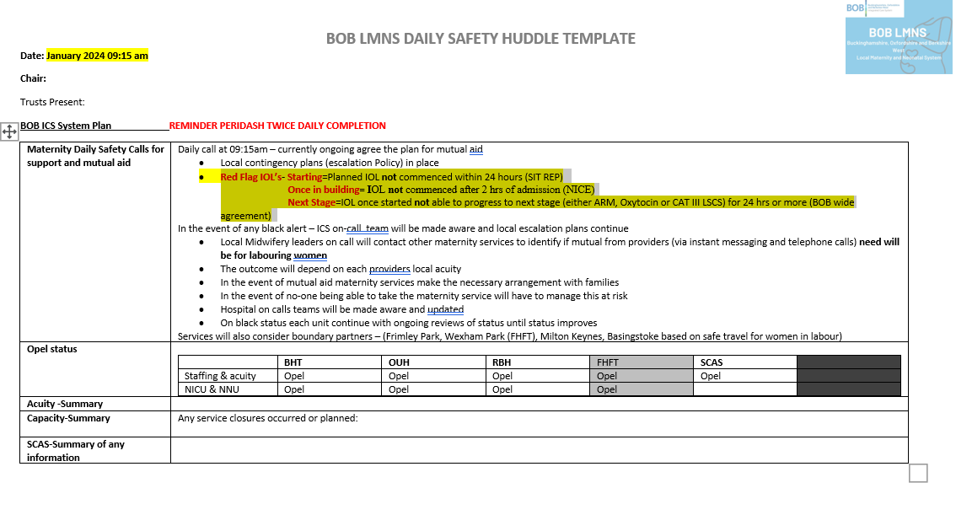
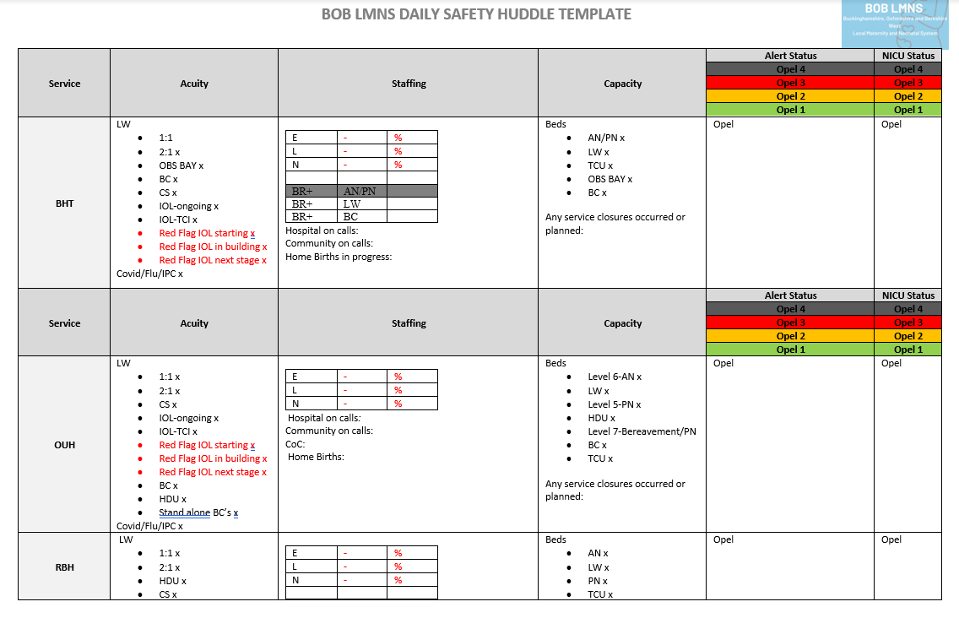

Appendix 2 Mutual Aid Guidance and Escalation Levels Framework for Buckinghamshire Oxfordshire and Berkshire West Local Maternity and Neonatal System



